 | 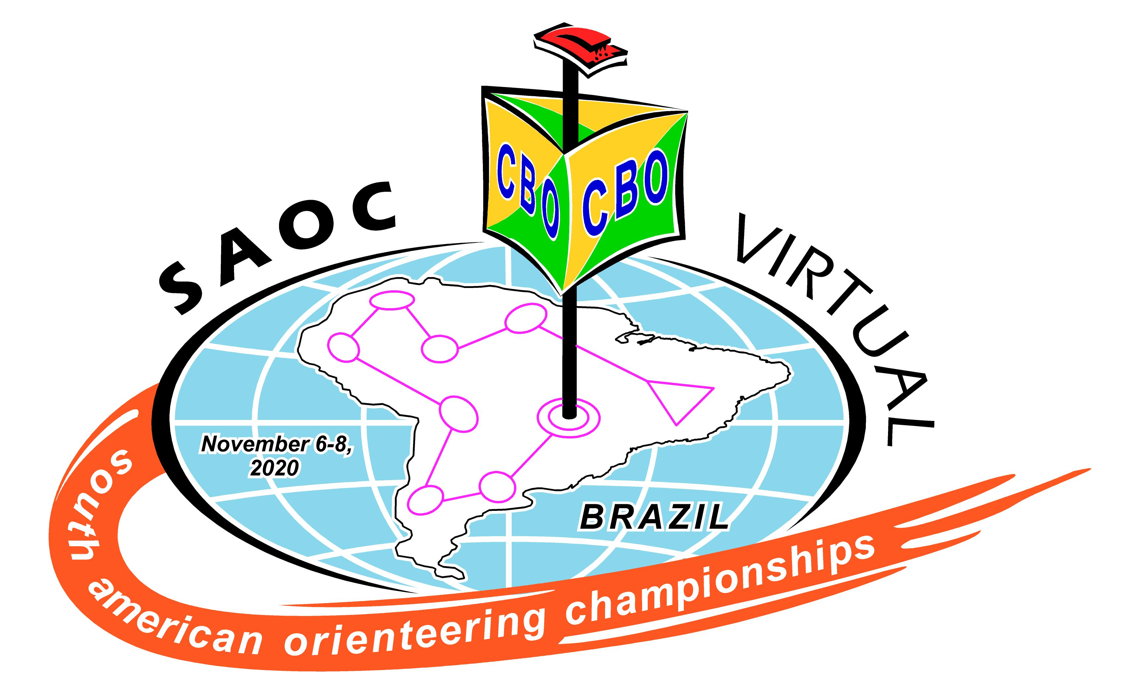 | 
P R O T E S T

Event: SOUTH AMERICAN VIRTUAL ORIENTEERING CHAMPIONSHIPS

Country: Brazil Period: 6 to 8, November 2020

Course: ................................................ Date: ........./11/2020 Time: ................ h

No. | Athlete | Class | Country/Federation
(make you complaint based on the IOF Rules, the Event Rules and official published documents)

Request ..........................................................................................................................................................................
.............................................................................................................................................................................................
.............................................................................................................................................................................................
............................................................................................................................................................................................
.............................................................................................................................................................................................
.............................................................................................................................................................................................
.............................................................................................................................................................................................
.............................................................................................................................................................................................
.............................................................................................................................................................................................
.............................................................................................................................................................................................

.........................................................., .......... / November 2020
(place)

_____________________________
Athlete’s signature

JURY DECISION |  |  | Time ................................. h
Signature:  _____________________  IOF SEA/Controller | Signature:  ____________________  Jury Member 1 | Signature:  ______________________  Jury Member 2 |  | Signature:  ______________________  Jury Member 3

I hereby declare, to the best of my knowledge, that the above information is the final Jury decision.

Date: ........../11/2020 | Time: ................... h |  | Date: ............/11/2020 | Time: ................... h
Signature:  ________________________  Organizer Representative |  |  | Signature:  ________________________  Claimant

